**ETL Project Report**

**Project Proposal**

**Project Title –** Is the Uninsured Population a Driver in Creating Health Professional Shortages?

**Team Members –** Lissette Miranda, Rodrigo Anglarill, Ganesh Crooks

**Description of the scope of our research:**

The objective of our project is to determine whether there is a correlation between the reported Uninsured Population in Florida and the designated Health Professional Shortage Areas (HPSAs) in the same state. We are attempting to discover whether there is enough evidence to conclude that the uninsured population is another cause of what’s causing Health Professional shortages

**Hypothesis**: Our group’s hypothesis is that where there is a large number of uninsured people, there is also a bigger gap in Health professional services provided in that area in comparison to other areas.

**Finding Data**

**Datasets:**

Our datasets came from CSV files. Sources:

**Dataset 1** - Health Provider Shortage (HPSA in FL by County: <https://factfinder.census.gov/faces/nav/jsf/pages/guided_search.xhtml>

**Dataset 2** - Uninsured Population in FL by County: <https://data.hrsa.gov/tools/shortage-area/hpsa-find>

**ETL Process:**

1. **EXTRACT**

From the websites we used to retrieve data, we extracted the data in CSV files that we cleaned up as follows:

1. Using Jupyter Notebook, we .read both csv files:





1. **TRANSFORM**

From the data extracted, our cleaning process was as follows:  
Steps:

1. Removed columns on both datasets that were not relevant.
2. Renamed columns for clarity of content and manipulation.
   1. **Dataset 1** – HPSAs:

* We removed fields without a physical location (see note under image)
  1. **Dataset 2** – Uninsured:
* Edited county name fields to remove “Florida” from name for merging later on
* Removed row with FL totals from dataset and saved these “totals” outside of our dataset for analysis later on. Renamed columns





**Note:** We removed fields that lacked a physical location because we will focus on areas that have reported (designated) a shortage of physical, facility-type places that provide health services to the population. Fields that lacked a physical location were specific to doctors, healthcare providers (people).



1. **LOAD**

**Steps:**

1. We loaded the data into a relational database (MySQL)
   1. Created database named “medical_desert_db”
   2. Created 2 tables: “hpsa”, “uninsured”

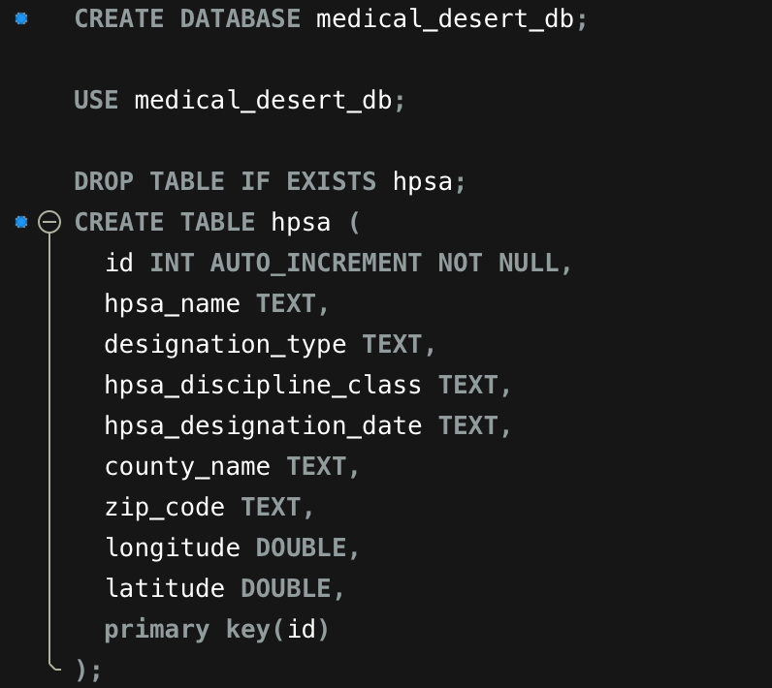

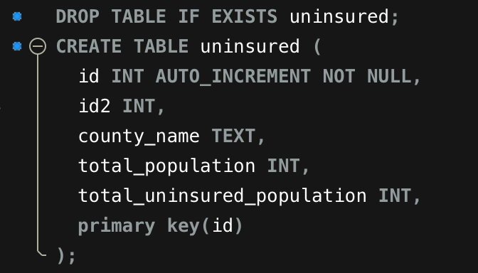

1. In Jupyter Notebook, we connected to our local database
2. Loaded both dataframes into Jupyter (hpsa and uninsured)
3. Merged both tables on a common field (county)

**LOAD into Jupyter:**

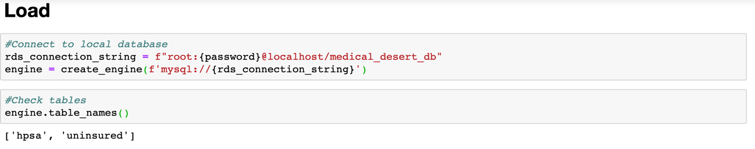

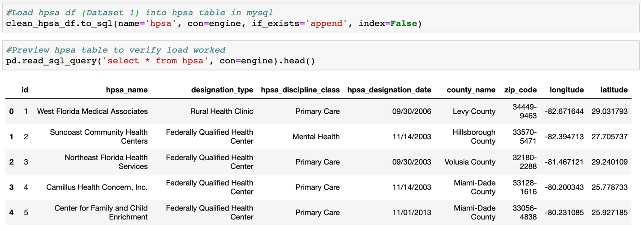

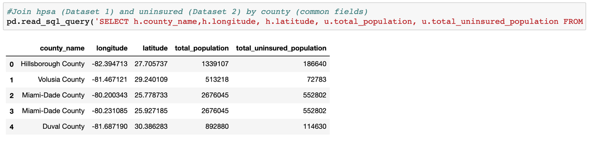

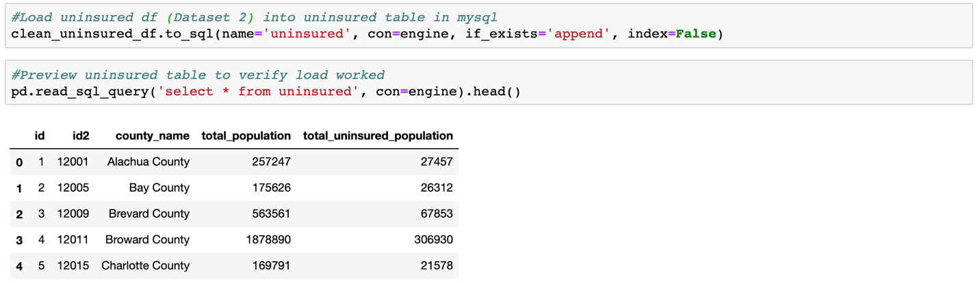

**ANALYSIS**

**Hypothesis:** Where there is a large number of uninsured people, there is also a bigger gap in Health professional services provided in that area in comparison to other areas.

**Analysis**:

In order to see whether or not there was a correlation between the rate of uninsured population by county and the locations of medical deserts (Health Provider Shortage) within those counties, we decided to construct a plot showing Florida’s map where we layered both characteristics on top of one another as follows: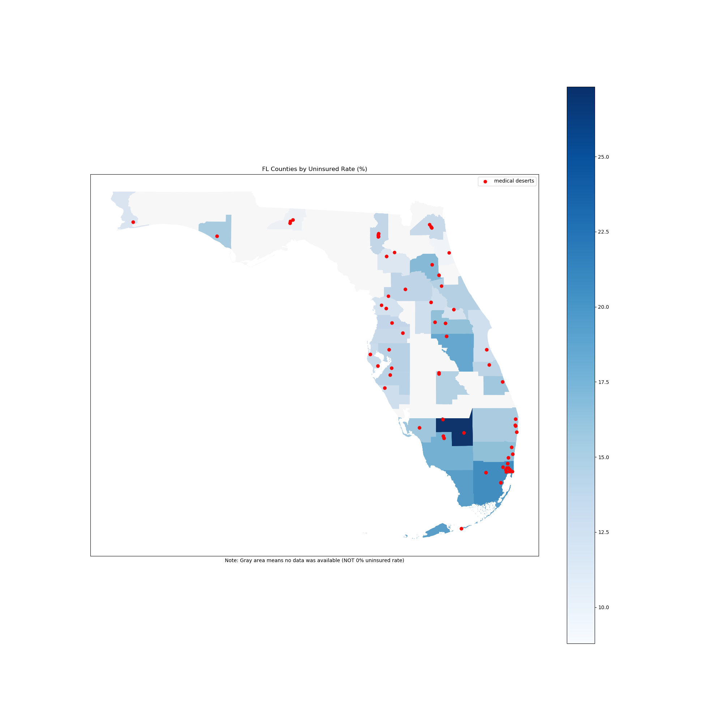

* In this plot, the darker the shade of **blue**, the higher the rate of uninsured population in that county.
* Counties where no information on uninsured population and health professional shortage was reported are shown in **light gray**
* The **red** dots represent the areas where a shortage of health professional services was reported.

After taking a closer look at the visual presented, we noticed that:

* The county where the highest rate of uninsured was reported, has 2 areas designated as “health professional shortage” areas. While, areas with a lower rate of uninsured have a higher number of areas designated as “health professional shortage” areas.

At this time, even though some areas such as Miami-Dade-County have a high rate (> 20%) of uninsured population and also show a high number of shortage areas, we noticed that this isn’t always the case. Therefore, we cannot conclude with confidence that a relationship exists between the two characteristics we set out to research in our project.

Further research would need to be done in order to take into account other factors that could contribute to the number of shortage areas reported, such as:

* Specific types of facilities reported in “shortage areas” *(e.g. inpatient hospital, health centers, non-profit, for-profit, clinics, urgent care centers, etc.)*
* Income level in the county or nearby counties *(does an overall population with medium to high income compensate for the uninsured population, therefore allowing health centers to stay open?)*
* Population (volume) in the county, the higher the population the more these counties might get prioritized in terms of health center placement (*typically the higher the population the more healthcare providers are needed*)
* Overall population demographics *(Is the population mostly elderly? High level of illness reported? Lifestyle?)*
* Among others.